# ***Ahsanullah University of Science & Technology***

Department of Computer Science & Engineering



CSE 3216

Microcontroller Based System Design Lab

Project Title : Fingerprint Student Attendance System

Submission Date : 15/04/2019

Submitted By:

A.H.M Annur 16.01.04.087

Sumaiya Rahman 16.01.04.088

Mohimenul Islam Razib 16.01.04.096

Abir Hossain Xian 16.01.04.100

**Introduction:** In our country every school, collage, university, corporate office has an attendance calling system. For now, attendance calling for school, collage, university takes around 10-15 mins. Our system is a automated attendance system with finger print input system that will make the attendance process lot more faster and easier in our county. We are looking forward to make a industrial level device that can be used anywhere in any environment.

**Components:**

**Hardware Components:**

* **Arduino UNO REV3** – used as a microcontroller.
* **20x4 LCD** – used to see all data and manage stuffs
* **R305 Fingerprint module** – use to input fingerprints
* **ESP8266 Wi-Fi Module** – gives microcontroller access to Wi-Fi network.

In our project it is used to connect with student’s mobiles and capture MAC address generated in that device.

* **Mini circuit Boards** – use to solve the common connections / extra connection between Arduino & other hardware components.
* **Male/Female Jumper Wires** – use to give connection between two points/ports.
* **Resistances** – use with the LCD.
* **Keypad** – use to make the controller

**Software Components:**

* Arduino IDE – for burning code on Arduino UNO REV3.
* Proteus –to design the hardware component model.

**Features:**

* The device will be portable.
* Visualization of student attendance with the LCD screen
* Basically, initially the device will get fingerprint from the students for registration.
* Then every time a student enters a class, he/she will put his/her finger to give the attendance.
* Our device will receive the fingerprint and match it with the registered fingerprints and give attendance of that class to the student.
* A teacher is the main operator of this device.
* Teacher will start the attendance count by giving his course id after that student can enter their finger to get the attendance in a very fast way.
* Our device is anti-proxy system, there is near zero percent chance that in a class 2 people will have the same finger print. So, no one can give any proxy.
* Our UI will be very simple.

**Working Principle:**

* First there will be a main menu. Options are given below-
  + Take Attendance
    - Teacher will enter course number to start the attendance system
      * Attendance system will auto magically wait for each student’s finger
    - After getting attendance teacher will stop the system
  + Add Students
    - For adding student, first need to enter Student id then system will ask for their finger.
    - After giving the fingerprint system will register the student
  + See Attendance
    - Here Teacher can have a short look on the presented ID’s
    - Also, teacher can clear the attendance if he wants to.
  + Send data to server
    - Here System will send all the presented data to the server.
    - Teacher can see the data from the server after this step

**Circuit Diagram:**

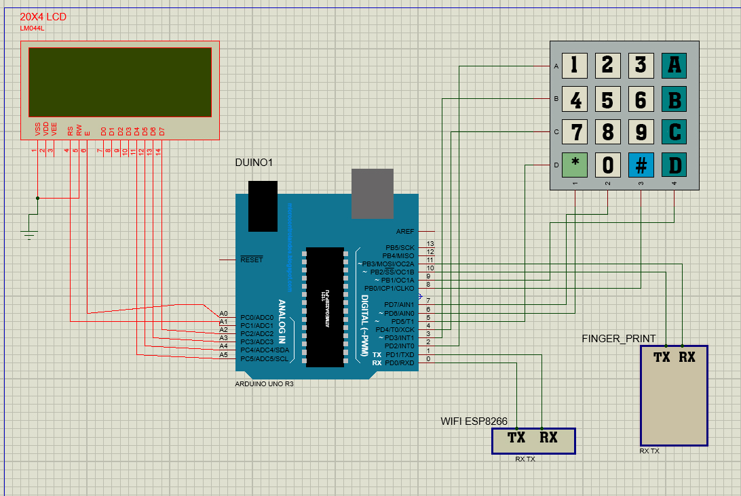

**Figures of the project:**

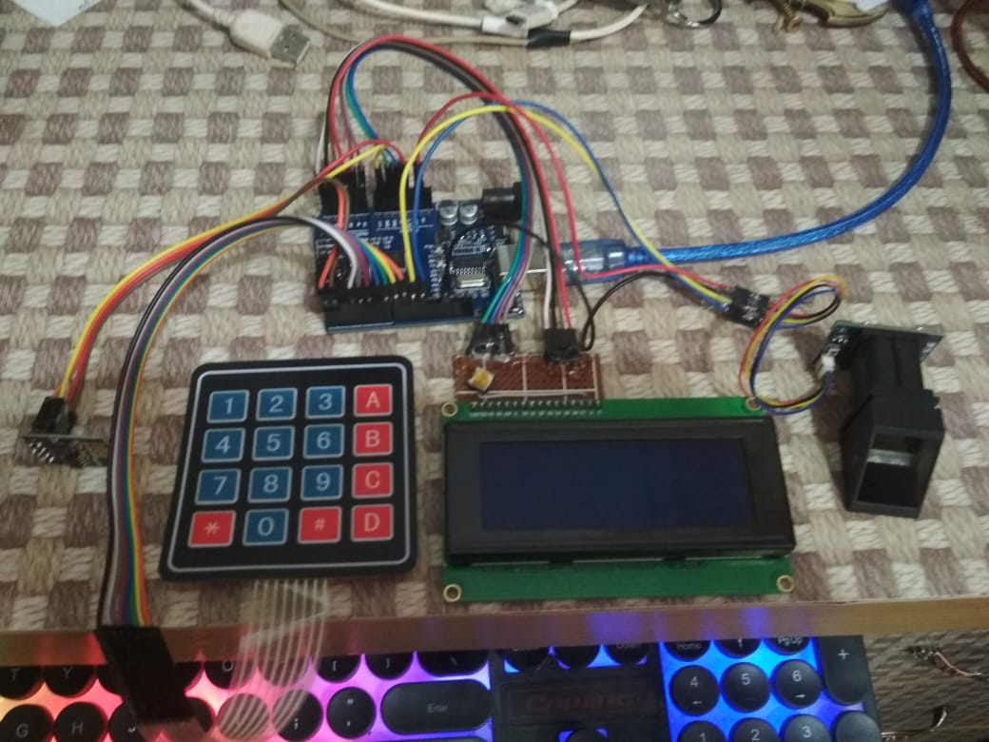

**Constrains:**

**Connecting LCD with the Arduino was little hard.**

**Also operating WiFi module with command needed a lot of study about it.**

**Dos and Don’ts:**

|  |  |  |
| --- | --- | --- |
| **Key Features** | **Does** | **Doesn’t** |
| **LCD Display** | **20x4 LCD** | **Graphic LCD** |
| **Push Button** |  | **Failed to add** |
| **KeyPad** | **Added successfully** |  |
| **Fingerprint module** | **Added successfully** |  |
| **Wi-Fi Module** | **Added successfully** |  |

**Conclusion:** In the end we can say that it’s a prototype of a very large project. If we can pull it of by a cheaper cost it will be very helpful to all of our educational institution of our country.

**Appendix:**

Arduino Code:

|  |
| --- |
| #include <Wire.h>  #include <LiquidCrystal.h>  #include <Keypad.h>  #include <Adafruit_Fingerprint.h>  #include <SoftwareSerial.h>  int displayMode = 0;  int tempID = 0;  String courseNo = "";  String ATTEND_STR = "ID : ";  //WIFI  #define wifi Serial  String wifiSSID = "MSD_STUDENT";  String wifiPASS = "123456789";  String HOST = "192.168.0.105";  String PORT = "5000";  String rxd, getData;  bool connectFlag = false;  //finger print  SoftwareSerial mySerial(10, 11); //RX,TX  Adafruit_Fingerprint finger = Adafruit_Fingerprint(&mySerial);  int id ,getId;  bool fig = false;  //LiquidCrystal lcd(RS, E, D4, D5, D6, D7)  LiquidCrystal lcd(A1, A0, A5, A4, A3, A2);  //KEYPAD  const byte rows = 4;  const byte cols = 4;  char keys[rows][cols] = {  {'1','2','3','A'},  {'4','5','6','B'},  {'7','8','9','C'},  {'*','0','#','D'}  };  byte rowPin[] = {2,3,4,5};  byte colPins[] = {6,7,8,9};  Keypad kpd = Keypad(makeKeymap(keys),rowPin, colPins, rows, cols);  void setup()  {    //WiFi  wifi.begin(9600);    //LCD  lcd.begin(20, 4);  //lcd.print("XIAN");  //FINGER PRINT  finger.begin(57600);    if(finger.verifyPassword()){  //Serial.println("Found fingerprint sensor!");  }else{  //Serial.println("Did not find fingerprint sensor :(");  }  }  void loop()  {  //while(connectFlag == false) wifi_init();  //if(figer) getId = matchFinger();    if(displayMode == 0){  printMainMenu();  }else if(displayMode == 1){  printAddStudent();  }else if(displayMode == 2){  printTakeAttend();  }else if(displayMode == 3){  printTakingAttendance();  }else if(displayMode == 4){  printAttendedStudents();  }else if(displayMode == 5){  sendDataToServer();  }      }  void printAttendedStudents(){  lcd.setCursor(0,0);  lcd.print(ATTEND_STR);  lcd.setCursor(0,3);  lcd.print("B: BACK C: CLEAR");  char x = kpd.getKey();  if(x){  if(x == 'B'){  displayMode = 0;  lcd.clear();  }else if(x == 'C'){  ATTEND_STR = (String)"ID : ";  lcd.clear();  lcd.setCursor(0,2);  lcd.print("ATTENDANCE CLEARED!");  sendData("CLEAR");  delay(1500);  displayMode = 0;  lcd.clear();  }    }  }  void sendDataToServer(){  lcd.setCursor(0,1);  lcd.print("SENDING DATA.");  delay(200);  lcd.print(".");  delay(200);  lcd.print(".");  delay(200);  lcd.print(".");  delay(200);  lcd.print(".");  delay(200);  lcd.print(".");  sendData("PRINT");  delay(500);  lcd.setCursor(0,3);  lcd.print("<<<<<<<<DONE>>>>>>>>");  delay(1500);  displayMode = 0;  lcd.clear();    }  void printMainMenu(){  //lcd.clear();  lcd.setCursor(0,0);  lcd.print("A: TAKE ATTENDANCE");  lcd.setCursor(0,1);  lcd.print("B: ADD STUDENT");  lcd.setCursor(0,2);  lcd.print("C: SEE ATTENDANCE");  lcd.setCursor(0,3);  lcd.print("D: SEND DATA");  char x = kpd.getKey();  if(x){  if(x == 'A'){    displayMode = 2;  lcd.clear();    }else if(x == 'B'){    displayMode = 1;  lcd.clear();    }else if(x == 'C'){  displayMode = 4; //See Attended Students  lcd.clear();    }else if(x == 'D'){  displayMode = 5; //Send Data to server  lcd.clear();  }  }    }  void printTakeAttend(){  lcd.setCursor(0,0);  lcd.print("ENTER COURSE : ");  //lcd.setCursor(0,10);  lcd.setCursor(0,3);  lcd.print("A: DONE");  lcd.setCursor(11,3);  lcd.print("B: CANCEL");  lcd.setCursor(0,1);  char x = kpd.getKey();  if(x){  if(x == 'A'){    displayMode = 3; //Start Attandence  lcd.clear();    }else if(x == 'B'){  displayMode = 0;  lcd.clear();  }else{  courseNo += x;  lcd.print(courseNo);  }    }    }  void printTakingAttendance(){  lcd.setCursor(0,0);  lcd.print("ATTENDANCE STARTED!!");  lcd.setCursor(0,1);  lcd.print("ENTER YOUR FINGER");  lcd.setCursor(0,3);  lcd.print("A: STOP");  char x = kpd.getKey();  if(x){  if(x == 'A'){  lcd.clear();  lcd.setCursor(0,2);  lcd.print("ATTENDANCE FINISHED");  courseNo = "";  delay(1000);  displayMode = 0;  lcd.clear();  }  }else{  getId = matchFinger();    if(getId != -1){  lcd.setCursor(0,2);  lcd.print(" ");  lcd.setCursor(0,2);  lcd.print("PRESENT ID : "+(String)getId);  sendData(courseNo+","+(String)getId);  ATTEND_STR += ", "+(String)getId;  delay(2000);  lcd.setCursor(0,2);  lcd.print(" ");  lcd.setCursor(0,2);  lcd.print("NEXT STUDENT");    }else{  }  delay(250);    }    }  void printAddStudent(){  lcd.setCursor(0,0);  lcd.print("Enter ID : ");  //lcd.setCursor(0,10);  lcd.setCursor(0,3);  lcd.print("A: ADD");  lcd.setCursor(11,3);  lcd.print("B: CANCEL");  lcd.setCursor(11,0);  char x = kpd.getKey();  if(x){  if(x == 'A'){  id = tempID;  tempID = 0;  lcd.setCursor(0,2);  lcd.print("ADDING ID : "+(String)id);  delay(1000);  lcd.clear();    addStudent();    }else if(x == 'B'){  displayMode = 0;  lcd.clear();  }else{  tempID *= 10;  tempID += (int)x -48;    lcd.print(tempID);  }    }    }  void addStudent(){  lcd.setCursor(0,0);  lcd.print("ENTER FINGER FOR");  lcd.setCursor(0,1);  lcd.print("ID = "+(String)id);  bool enroll = fingerEnroll(id);  if(enroll == true){  lcd.clear();  lcd.setCursor(0,0);  lcd.print("STUDENT REGISTERED!");  lcd.setCursor(0,2);  lcd.print("STUDENT ID = "+(String)id);  delay(1500);  displayMode = 0;  lcd.clear();  }  }  bool fingerEnroll(int id) {  int p = -1;  //Serial.print("Waiting for valid finger to enroll as #"); Serial.println(id);  while (p != FINGERPRINT_OK) {  p = finger.getImage();  }    p = finger.image2Tz(1);  if (p != FINGERPRINT_OK) return false;    p = -1;  while (p != FINGERPRINT_OK) {  p = finger.getImage();  }    p = finger.image2Tz(2);  if (p != FINGERPRINT_OK) return false;    //Serial.print("Creating model for #"); Serial.println(id);    p = finger.createModel();  if (p != FINGERPRINT_OK) return false;    //Serial.print("ID "); Serial.println(id);  p = finger.storeModel(id);  if (p != FINGERPRINT_OK) return false;  return true;  }  int matchFinger(){  uint8_t p = finger.getImage();  if (p != FINGERPRINT_OK) return -1;  p = finger.image2Tz();  if (p != FINGERPRINT_OK) return -1;  p = finger.fingerFastSearch();  if (p != FINGERPRINT_OK) return -1;  //Serial.print("Found ID #"); Serial.println(finger.fingerID);  //lcd.print("#"+finger.fingerID);  return finger.fingerID;  }  void wifi_init(){  //------------------------------ configuration  digitalWrite(LED_BUILTIN, HIGH);  //wifi.listen();  wifi.println((String)"AT+CWJAP=\"" + wifiSSID + "\",\"" + wifiPASS + "\"");  delay(100);  if(wifi.available() > 0){  rxd = wifi.readString();  if(rxd.indexOf("GOT IP") != -1) {  connectFlag = true;  wifi.println((String)"AT+CIPSTART=\"TCP\",\"" + HOST + "\","+PORT +"");  delay(50);  digitalWrite(LED_BUILTIN, LOW);  }  rxd = "";  }  }  void sendData(String msg){  digitalWrite(LED_BUILTIN, HIGH);  int digit = msg.length() + 2;  wifi.println((String)"AT+CIPSTART=\"TCP\",\"" + HOST + "\","+PORT +"");  delay(50);  wifi.println((String)"AT+CIPSEND=" + digit);  delay(50);  wifi.println(msg);  delay(50);  digitalWrite(LED_BUILTIN, LOW);  } |

Server-Side Code:

|  |
| --- |
| ArrayList<String> STUDENTS = new ArrayList();    try {  while(true){  ss = new ServerSocket(5000);  s = ss.accept();    //System.out.println("Server is running");    isr = new InputStreamReader(s.getInputStream());  br = new BufferedReader(isr);  message = br.readLine();  //System.out.println(message);    if(message.equals("PRINT")){  System.out.println("PRESENT DATA: "+STUDENTS.size());  for(int i=0;i<STUDENTS.size();i++){  System.out.println(STUDENTS.get(i));  }  }else if(message.equals("CLEAR")){  STUDENTS.clear();  System.out.println("PRESENT CLEARED:");    }else{  String[] dataArray = message.split(",");  STUDENTS.add("STUDENT ID\t"+dataArray[1]+"\tPRESENT ON COURSE\t"+dataArray[0]);    }    isr.close();  br.close();  ss.close();  s.close();      }  } catch (IOException ex) {  Logger.getLogger(MyServer.class.getName()).log(Level.SEVERE, null, ex);  } |